MSBTE Result Analysis Automation - Technical Documentation

Table of Contents
- Application Overview
- System Architecture
- Module Breakdown
- Data Flow
- Processing Pipeline
- User Interface Components
- Excel Generation Process
- Error Handling

1. Application Overview
The MSBTE Result Analysis Automation is a desktop application designed to streamline the process of fetching student examination results from the Maharashtra State Board of Technical Education (MSBTE) portal and generating comprehensive Excel reports with detailed analysis.

Purpose
- Automate manual result fetching for multiple students
- Generate formatted Excel reports matching institutional standards
- Provide subject-wise analysis and statistical summaries
- Identify toppers and overall class performance

Key Capabilities
- Batch processing of student seat numbers
- Web scraping with configurable delays
- Automated Excel report generation with formulas
- Real-time progress tracking
- Subject-wise pass/fail analysis

2. System Architecture

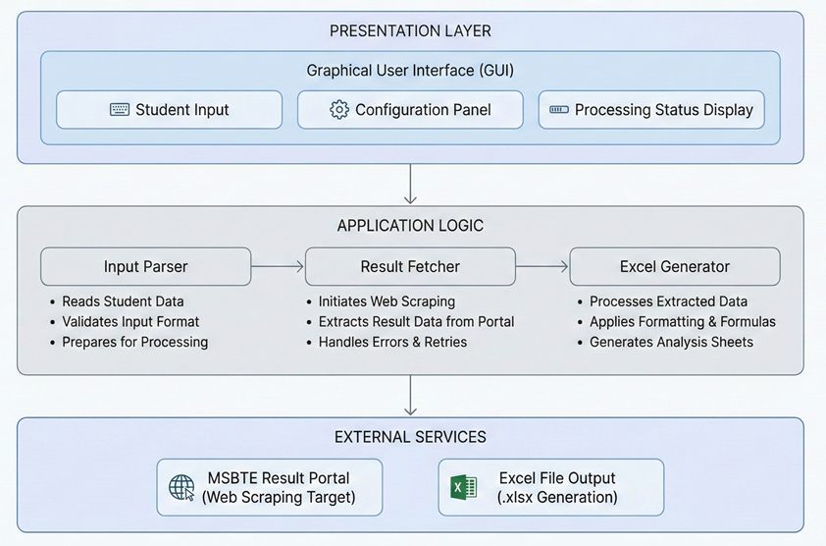
Figure 1– System Architecture Diagram

Component Interaction Flow
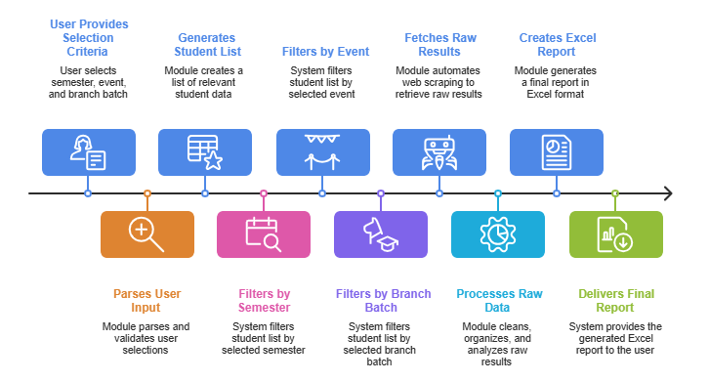
Figure 2-Component Flow

3. Module Breakdown

3.1 Configuration Module
Purpose: Manages application-wide settings and constants
Key Responsibilities: - Define semester mappings (S1, S2, S3, etc.) - Store color schemes for Excel formatting - Maintain request delay configurations - Browser automation settings
Configuration Categories: - Academic Settings: Semester codes, exam events (Winter/Summer) - Excel Formatting: Header colors, result classification colors (FCD, FC, SC, Fail) - Automation Settings: Request delays, headless mode options - UI Themes: Dark theme color palette for the interface

3.2 Input Parser Module
Purpose: Handles multiple input methods for student data entry
Input Methods Supported: 1. File Upload: Excel/CSV files containing seat numbers 2. Text Input: Direct paste of seat numbers with line separation 3. Format Detection: Automatic recognition of input format
Processing Stages: - Validation: Checks for valid seat number formats - Deduplication: Removes duplicate entries - Normalization: Standardizes seat number format - Count Reporting: Reports total students loaded
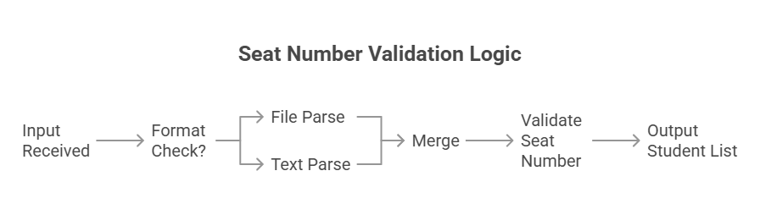
Figure 3-Seat Validation Logic

3.3 Result Fetcher Module
Purpose: Automates web interaction with MSBTE portal
Core Functionality: - Browser Automation: Controls web browser programmatically - Form Navigation: Navigates to result pages automatically - Data Extraction: Scrapes result data from HTML responses - Session Management: Handles cookies and session states
Fetching Process: 1. Portal Navigation: Opens MSBTE result portal 2. Form Population: Enters semester, seat number, event 3. Submission: Triggers result search 4. Response Parsing: Extracts data from HTML tables 5. Data Structuring: Organizes marks by subject
Data Extracted Per Student: - Personal Information: Name, Enrollment Number, Seat Number - Subject-wise Marks: - Theory Components (FA-TH, SA-TH, Total TH) - Practical Components (FA-PR, SA-PR, Total PR) - Sessionals/SLA marks - Overall Performance: Grand Total, Percentage, Result Classification
Retry Mechanism: - Implements exponential backoff for failed requests - Configurable retry attempts - Error logging for failed fetches

3.4 Data Processor Module
Purpose: Transforms raw scraped data into structured format
Processing Steps: 1. HTML Parsing: Extracts tabular data from HTML 2. Subject Identification: Maps subject codes to full names 3. Mark Extraction: Parses individual component marks 4. Result Classification: Categorizes as FCD, FC, SC, Fail, ATKT
Classification Logic:
Percentage Range | Classification | Short Form
≥ 70% | First Class with Distinction | FCD
60% – 69.99% | First Class | FC
50% – 59.99% | Second Class | SC
40% – 49.99% | Pass Grade | —
< 40% | Fail / ATKT | Fail / ATKT
Table 1 – Classification of Percentage
Data Structure Organization: - Hierarchical organization: Student → Subjects → Marks - Handles variable subject structures (different semesters) - Preserves original mark components (FA, SA, Totals)

3.5 Excel Generator Module
Purpose: Creates formatted Excel reports with analysis
Report Sections: 1. Header Section: Title, exam event, branch/batch info 2. Student Data Table: Individual student marks 3. Subject-wise Analysis: Statistical breakdown per subject 4. Overall Summary: Pass/fail statistics 5. Toppers Section: Rank-wise top performers
Formatting Features: - Conditional Formatting: Color-codes results (FCD=green, Fail=red) - Borders & Alignment: Professional table formatting - Formula Integration: Auto-calculated percentages and statistics - Freeze Panes: Keeps headers visible during scrolling
Analysis Statistics Generated: - Lowest/Highest marks per subject - Number of students appeared - Number of students passed - Pass percentage - Students scoring above 60%

4. Data Flow

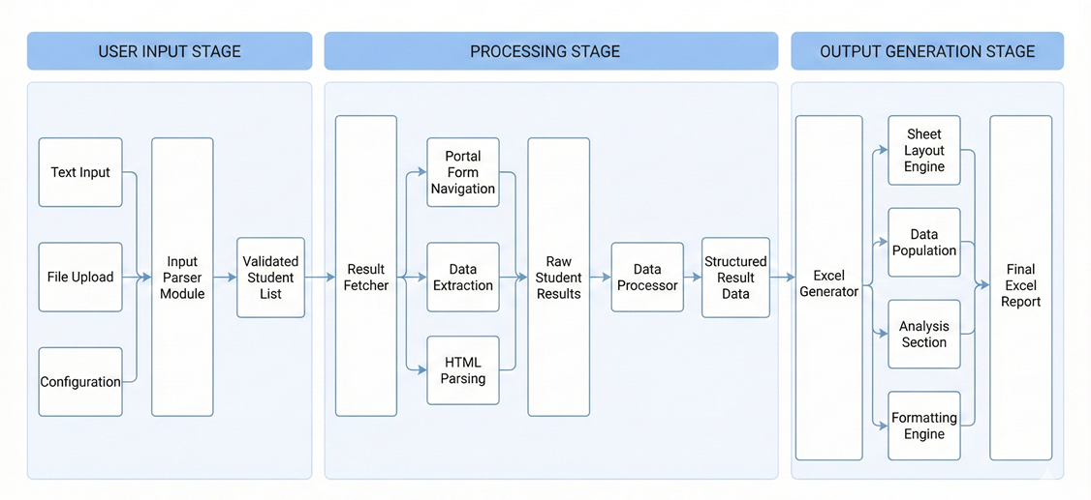
Figure 4- Data Flow Diagram

Data Transformation Flow
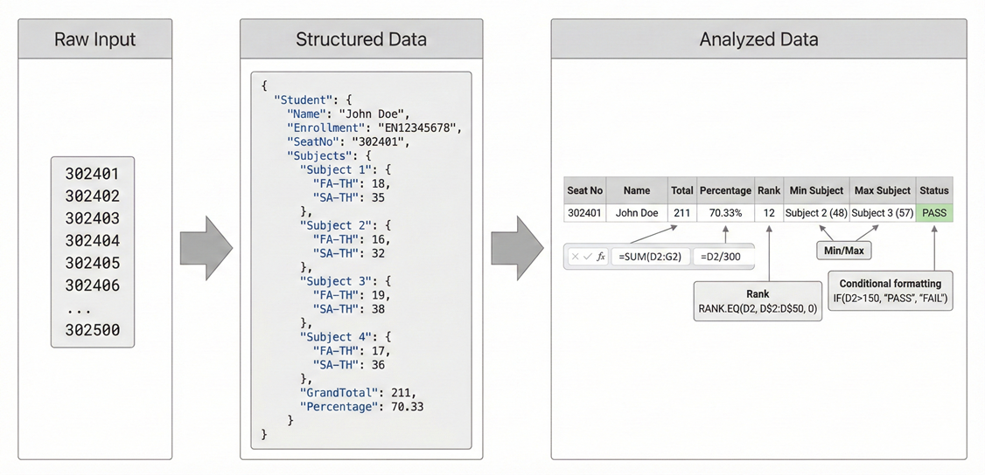
Figure 5-Data Transformation Flow Diagram

5. Processing Pipeline

Pipeline Stages
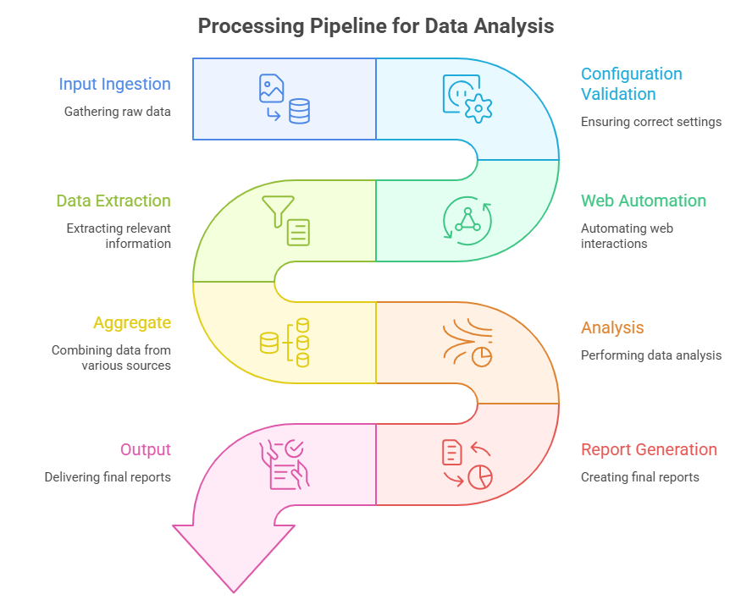
Figure 6-Application Process Pipeline

6. User Interface Components

Layout Architecture

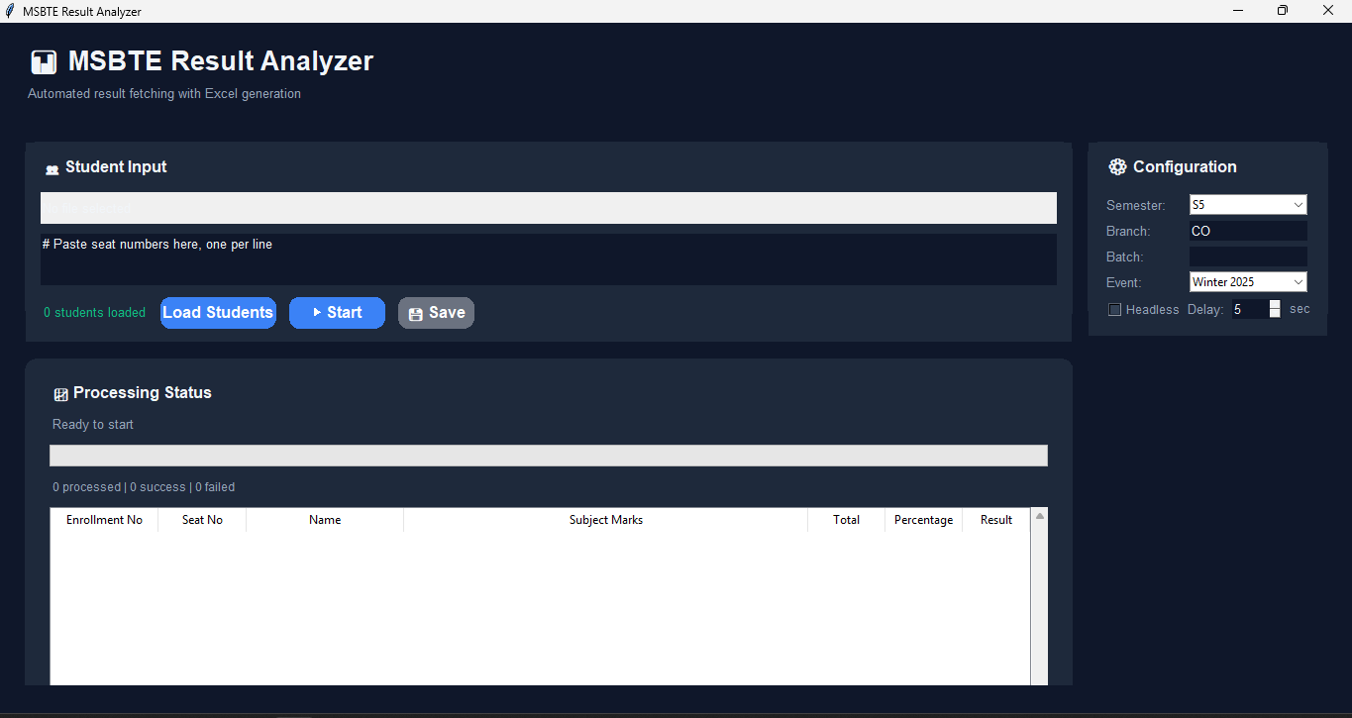
Figure 7- Overall GUI and Layout of Software

Component Interactions
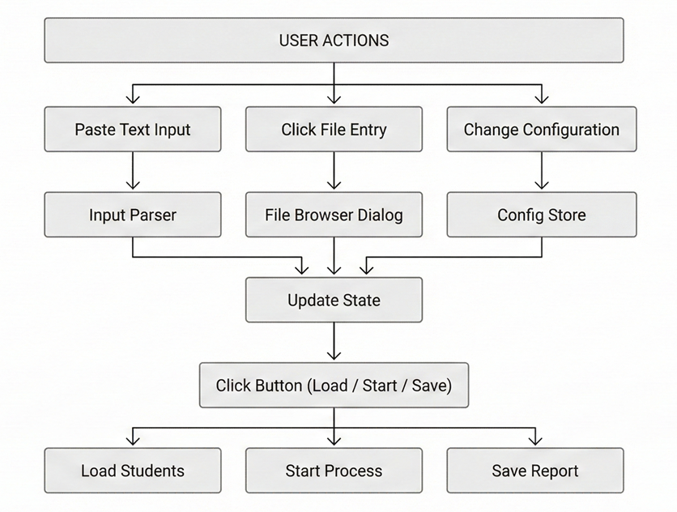
Figure 8- User Interaction Flow Diagram

7. Excel Generation Process

Sheet Structure

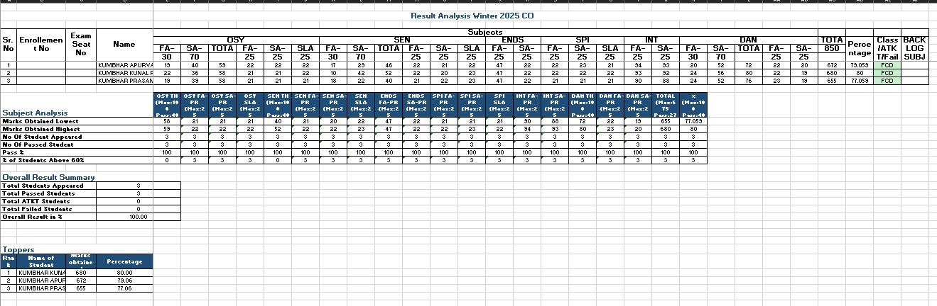
Figure 9-Excel sheet Structure

Formula Integration
Formulas Used in Report:
1. THEORY TOTAL (for FA-TH + SA-TH structure):
Formula: ={FA-TH_Cell}+{SA-TH_Cell}
Example: =E8+F8 (where E8=FA-TH, F8=SA-TH)
2. GRAND TOTAL:
Formula: ={TOTAL_Cell}
Uses portal's provided total or calculated sum
3. PERCENTAGE:
Formula: =({TOTAL_Cell}/{MAX_MARKS})*100
Example: =(M8/850)*100
4. PASS COUNT (in analysis):
Formula: =COUNTIF({Range},">={PASSING_MARKS}")
Example: =COUNTIF(E8:E52,">=40")
5. PASS PERCENTAGE:
Formula: =IF({APPEARED}>0,{PASSED}/{APPEARED}*100,0)
Example: =IF(COUNT(E8:E52)>0,COUNTIF(E8:E52,">=40")/COUNT(E8:E52)*100,0)
6. MINIMUM MARKS:
Formula: =MIN({Range})
Example: =MIN(E8:E52)
7. MAXIMUM MARKS:
Formula: =MAX({Range})
Example: =MAX(E8:E52)
8. STUDENTS ABOVE 60%:
Formula: =COUNTIF({Range},">={60%_OF_MAX}")
Example: =COUNTIF(E8:E52,">=60")

8. Error Handling

Error Handling Flowchart
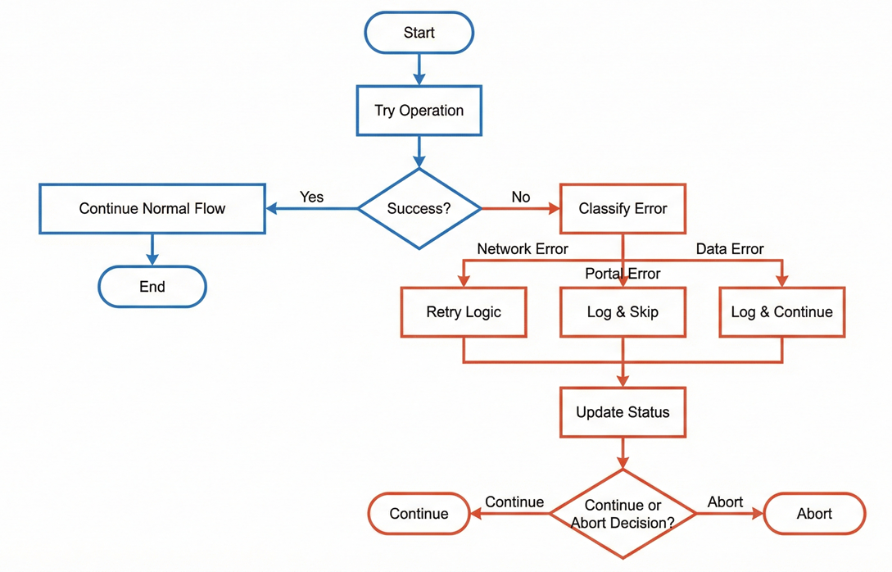Figure 10- Error Handling System

Error Categories
- Network/Connection Errors
  - Timeout during portal access
  - Internet connectivity issues
  - DNS resolution failures
  - SSL certificate errors
- Portal-Specific Errors
  - Invalid seat number (not found)
  - Server maintenance/down
  - Captcha requirement detected
  - Session expiration
  - Rate limiting
- Data Parsing Errors
  - HTML structure changes
  - Unexpected mark formats
  - Missing required fields
  - Encoding issues
- File/System Errors
  - File upload failures
  - Excel generation errors
  - Disk space issues
  - Permission errors

